  - Develop a Java program to create a Student class with data members such as Roll Number, Name, Branch, and CGPA. Create an object of the class, initialize the data, and display the student information using a method.
class Student {
int RollNumber; String Name; String Branch; double cgpa;
Student(int RollNumber, String Name, String Branch, double cgpa) { this.RollNumber = RollNumber;
this.Name = Name; this.Branch = Branch; this.cgpa = cgpa;
}
public void display() { System.out.println("Student Details");
// Appended the actual variables using '+' System.out.println("Roll Number: " + RollNumber); System.out.println("Name: " + Name); System.out.println("Branch: " + Branch); System.out.println("CGPA: " + cgpa);
}
public static void main(String[] args) {
Student s1 = new Student(153, "Kiran", "CSE AIML", 9.23); s1.display();
}
}

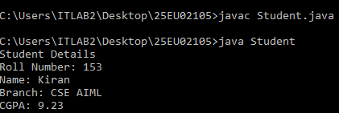
  - Develop a Java program to create an Employee class containing Employee ID, Name, Department, and Salary. Create an object of the class and display the employee details.
class Employee{ int empid; String name;
String department; float salary;
Employee(int empid,String name,String department,float salary){ this.empid=empid;
this.name=name; this.department=department; this.salary=salary;
}
public void display(){ System.out.println("Employee Details"); System.out.println("Employee ID: "+empid); System.out.println("Employee Name: "+name);
System.out.println("Employeee Department: "+department); System.out.println("Employee Salary: "+salary);
}
public static void main(String[] args){
Employee emp1=new Employee(112,"Sirisha","Software Developer",25000.50f); emp1.display();

}
}
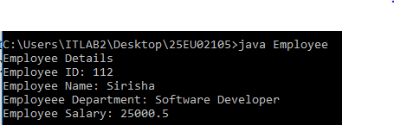
  - Write a Java program to declare and create three objects of a Book class. Display the details of all books using object references.
class Book{ String name; String author; double price;
Book(String name,String author,double price){ this.name=name;
this.author=author; this.price=price;
}
public void display(){ System.out.println("Book Name: "+name); System.out.println("Author: "+author); System.out.println("Book Price: "+price);
}
public static void main(String[] args){
Book b1=new Book("To Kill a Mockingbird", "Harper Lee", 14.99);

Book b2=new Book("1984", "George Orwell", 12.50);

Book b3=new Book("The Great Gatsby", "F. Scott Fitzgerald", 10.95); b1.display();
b2.display();
b3.display();
}
}
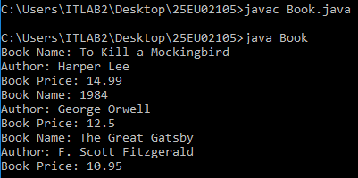

  - Write a Java program to create an array of five Student objects, accept their details from the user, and display all student information.
import java.util.Scanner; class Student {
private int id; private String name; private double cgpa;
public Student(int id, String name, double cgpa) { this.id = id;
this.name = name; this.cgpa = cgpa;
}
public void displayDetails() {
System.out.printf("ID: %d | Name: %s | CGPA: %.2f%n", id, name, cgpa);
}

}
public class ArrayStudent {
public static void main(String[] args) { Scanner scanner = new Scanner(System.in); Student[] students = new Student[5];
System.out.println("--- Enter Details for 5 Students ---"); for (int i = 0; i < students.length; i++) { System.out.println("\nStudent " + (i + 1) + ":"); System.out.print("Enter ID: ");
int id = scanner.nextInt(); scanner.nextLine(); System.out.print("Enter Name: "); String name = scanner.nextLine(); System.out.print("Enter CGPA: "); double cgpa = scanner.nextDouble();
students[i] = new Student(id, name, cgpa);
}
System.out.println("\n--- Displaying All Student Details ---"); for (Student student : students) {
student.displayDetails();
}
scanner.close();
}
}

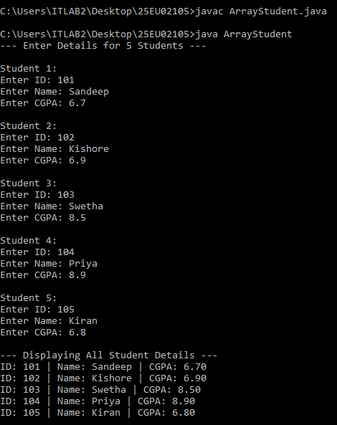
  - Develop a Java program to create a Student object and assign its reference to another reference variable. Modify the object through one reference and observe the changes using the other reference.
class Student { private String name; private int age;
public Student(String name, int age) { this.name = name;
this.age = age;

}
public void setName(String name) { this.name = name;
}
public String getName() { return this.name;
}
public void displayDetails(String variableName) { System.out.println(variableName + " -> Name: " + name + ", Age: " + age);
}
}
public class Main {
public static void main(String[] args) {
System.out.println("--- Step 1: Creating student1 object ---"); Student student1 = new Student("Alice", 20); student1.displayDetails("student1");
System.out.println("\n--- Step 2: Assigning student1 to student2 ---"); Student student2 = student1;
student1.displayDetails("student1"); student2.displayDetails("student2");
System.out.println("\n--- Step 3: Modifying name to 'Bob' using student2 ---"); student2.setName("Bob");
System.out.println("\n--- Step 4: Observing changes ---"); student1.displayDetails("student1"); student2.displayDetails("student2");
System.out.println("\nDoes student1 point to the same object as student2? " + (student1 == student2));
}
}

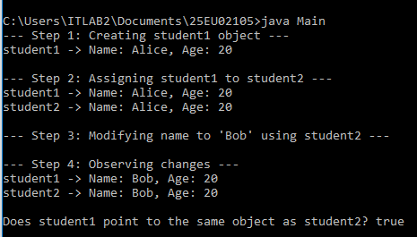
  - Write a Java program to create two reference variables pointing to the same Employee object. Compare the references using the == operator and display the result.
class Employee { String name; int id;

Employee(String name, int id) { this.name = name;
this.id = id;
}
}
public class EmployeeDemo {
public static void main(String[] args) {
Employee emp1 = new Employee("Alice", 101); Employee emp2 = emp1;

System.out.println("emp1 == emp2: " + (emp1 == emp2));
}
}

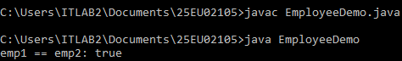
  - Develop a Java program to create a Calculator class with methods to perform addition, subtraction, multiplication, and division of two numbers.
class Calculator {

// Addition
public double add(double a, double b) { return a + b;
}

// Subtraction
public double subtract(double a, double b) { return a - b;
}

// Multiplication
public double multiply(double a, double b) { return a * b;
}

// Division with handling for division by zero public double divide(double a, double b) {
if (b == 0) {
System.out.println("Error: Division by zero is undefined."); return Double.NaN;
}
return a / b;
}

}

public class CalculatorDemo {
public static void main(String[] args) { Calculator calc = new Calculator();

double num1 = 20.0; double num2 = 4.0;

System.out.println("Numbers: " + num1 + " and " + num2); System.out.println("Addition: " + calc.add(num1, num2)); System.out.println("Subtraction: " + calc.subtract(num1, num2)); System.out.println("Multiplication: " + calc.multiply(num1, num2)); System.out.println("Division: " + calc.divide(num1, num2));

// Edge case check: Division by zero System.out.println("\nDivision by zero check:"); System.out.println("Result: " + calc.divide(num1, 0));
}
}
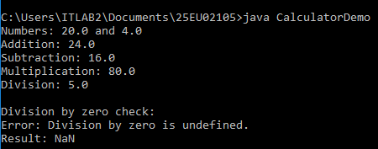

  - Write a Java program to create a Rectangle class with methods to calculate and display the area and perimeter of a rectangle.

class Rectangle { private double length; private double width;

// Constructor to initialize length and width public Rectangle(double length, double width) {
this.length = length; this.width = width;
}

// Method to calculate area public double calculateArea() {
return length * width;
}

// Method to calculate perimeter public double calculatePerimeter() {
return 2 * (length + width);
}

// Method to display rectangle details public void display() {
System.out.println("Length: " + length); System.out.println("Width: " + width); System.out.println("Area: " + calculateArea()); System.out.println("Perimeter: " + calculatePerimeter());
}
}

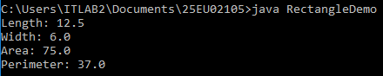
  - Develop a Java program to demonstrate the use of default and parameterized constructors for initializing student information.
class Student {
private String name; private int id; private double gpa;

// Default Constructor public Student() {
this.name = "Unknown"; this.id = 0;
this.gpa = 0.0;
}

// Parameterized Constructor
public Student(String name, int id, double gpa) { this.name = name;
this.id = id; this.gpa = gpa;
}

// Method to display student information public void displayStudentInfo() {
System.out.println("ID: " + id + " | Name: " + name + " | GPA: " + gpa);
}
}

public class StudentDemo {
public static void main(String[] args) {
// Initializing using the Default Constructor
System.out.println("--- Student initialized with Default Constructor ---"); Student student1 = new Student();
student1.displayStudentInfo();

System.out.println();

// Initializing using the Parameterized Constructor
System.out.println("--- Student initialized with Parameterized Constructor ---"); Student student2 = new Student("Alex Rivera", 1001, 3.85); student2.displayStudentInfo();
}
}
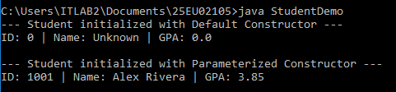
  - Write a Java program to demonstrate constructor overloading in a BankAccount class by creating objects using different constructors.
class BankAccount {
private String accountNumber; private String accountHolder; private double balance;

// Constructor 1: No arguments (Default values) public BankAccount() {
this.accountNumber = "UNASSIGNED"; this.accountHolder = "Guest";

this.balance = 0.0;
}

// Constructor 2: Two arguments (Account Number and Holder) public BankAccount(String accountNumber, String accountHolder) {
this.accountNumber = accountNumber; this.accountHolder = accountHolder;
this.balance = 0.0; // Default balance initialized to zero
}

// Constructor 3: Three arguments (Account Number, Holder, and Initial Balance) public BankAccount(String accountNumber, String accountHolder, double balance) {
this.accountNumber = accountNumber; this.accountHolder = accountHolder; this.balance = balance;
}

// Method to display account details public void displayAccountInfo() {
System.out.println("Acc No: " + accountNumber + " | Holder: " + accountHolder + " | Balance: $" + balance);
}
}

public class BankAccountDemo {
public static void main(String[] args) {
// 1. Using Default Constructor BankAccount acc1 = new BankAccount();

// 2. Using 2-parameter Constructor

BankAccount acc2 = new BankAccount("ACC-101", "Elena Rostova");

// 3. Using 3-parameter Constructor
BankAccount acc3 = new BankAccount("ACC-102", "Marcus Vance", 2500.50);

System.out.println("--- Account Details ---"); acc1.displayAccountInfo(); acc2.displayAccountInfo(); acc3.displayAccountInfo();
}
}
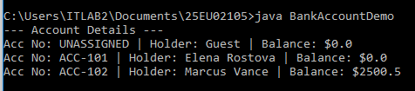
  - Develop a Java program to demonstrate the use of the this keyword to distinguish instance variables from local variables.
class Book {
// Instance variables private String title; private double price;

// Constructor parameters share the exact same names as instance variables public Book(String title, double price) {
// 'this.title' refers to the instance variable
// 'title' refers to the local parameter variable this.title = title;
this.price = price;
}

// Method with a local variable shadowing an instance variable public void updatePrice(double price) {
System.out.println("Updating price from " + this.price + " to " + price); this.price = price; // Resolves ambiguity between field and parameter
}

public void displayInfo() {
System.out.println("Book Title: " + this.title + " | Price: $" + this.price);
}
}

public class ThisKeywordDemo {
public static void main(String[] args) {
// Create an object using the parameterized constructor Book myBook = new Book("Effective Java", 45.00);

System.out.println("--- Initial Book Info ---"); myBook.displayInfo();

System.out.println("\n--- Updating Price ---"); myBook.updatePrice(49.99);

System.out.println("\n--- Updated Book Info ---"); myBook.displayInfo();
}
}

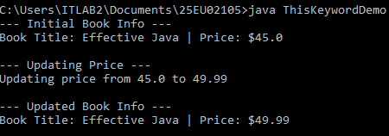
  - Write a Java program to demonstrate constructor chaining using the this() constructor in a Student class.
class Student { private int id;
private String name; private String course;

// Default constructor: Chains to the 2-parameter constructor public Student() {
this(0, "Unknown");
}

// 2-parameter constructor: Chains to the 3-parameter constructor public Student(int id, String name) {
this(id, name, "Undeclared");
}

// Target/Primary constructor that performs the actual initialization public Student(int id, String name, String course) {
this.id = id; this.name = name; this.course = course;
}

public void displayStudentInfo() {
System.out.println("ID: " + id + " | Name: " + name + " | Course: " + course);
}
}

public class ConstructorChainingDemo { public static void main(String[] args) {
// Calls 0-arg -> delegates to 2-arg -> delegates to 3-arg Student s1 = new Student();

// Calls 2-arg -> delegates to 3-arg Student s2 = new Student(101, "Sofia");

// Calls 3-arg directly
Student s3 = new Student(102, "Liam", "Computer Science");

System.out.println("--- Student Details ---"); s1.displayStudentInfo(); s2.displayStudentInfo(); s3.displayStudentInfo();
}
}
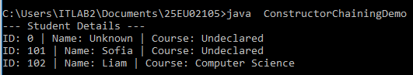
  - Develop a Java program to create multiple objects, make them eligible for garbage collection, and invoke System.gc().
class SampleObject { private int id;

public SampleObject(int id) { this.id = id;
System.out.println("SampleObject " + id + " created.");
}

// Overriding finalize to track when GC reclaims the object @Override
@SuppressWarnings("removal")
protected void finalize() throws Throwable { System.out.println("SampleObject " + id + " has been garbage collected.");
}
}

public class GarbageCollectionDemo { public static void main(String[] args) {
// Step 1: Create multiple objects SampleObject obj1 = new SampleObject(1); SampleObject obj2 = new SampleObject(2); SampleObject obj3 = new SampleObject(3);

// Step 2: Make objects eligible for Garbage Collection obj1 = null; // Unreferenced by nullifying
obj2 = null; // Unreferenced by nullifying
// obj3 remains active and pointed to by reference

System.out.println("\nRequesting Garbage Collection using System.gc()...\n");

// Step 3: Explicitly request Garbage Collection System.gc();

// Pause briefly to give the GC background thread time to run finalize() try {
Thread.sleep(1000);
} catch (InterruptedException e) { e.printStackTrace();
}

System.out.println("\nMain thread completed.");
}
}
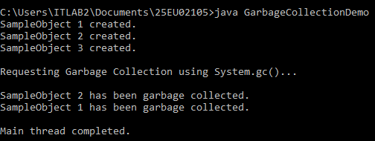
  - Write a Java program to demonstrate different ways of making objects eligible for garbage collection, such as null assignment, reassignment, and anonymous objects.
class DemoObject { private String name;

public DemoObject(String name) { this.name = name; System.out.println(name + " created.");
}
}

public class GCDemo {

public static void main(String[] args) { System.out.println("--- 1. Null Assignment ---"); DemoObject obj1 = new DemoObject("Object 1");
obj1 = null; // Object 1 is now unreferenced and eligible for GC

System.out.println("\n--- 2. Reassignment of Reference ---"); DemoObject obj2 = new DemoObject("Object 2"); DemoObject obj3 = new DemoObject("Object 3");
obj2 = obj3; // Object 2 reference is overwritten, making original Object 2 eligible for GC

System.out.println("\n--- 3. Anonymous Object ---");
new DemoObject("Object 4"); // Object 4 has no reference variable assigned, eligible immediately

System.out.println("\nRequesting Garbage Collection..."); System.gc();
}
}
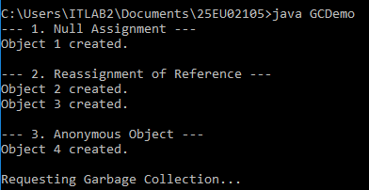
  - Develop a Java program to overload the add() method for different parameter lists. class Calculator {
public int add(int a, int b) { return a + b;
}

public int add(int a, int b, int c) { return a + b + c;
}

public double add(double a, double b) { return a + b;
}
}

public class MethodOverloadingDemo { public static void main(String[] args) {
Calculator calc = new Calculator();

System.out.println("Sum of 2 ints: " + calc.add(10, 20)); System.out.println("Sum of 3 ints: " + calc.add(10, 20, 30)); System.out.println("Sum of 2 doubles: " + calc.add(10.5, 20.5));
}
}
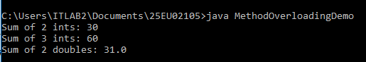
  - Write a Java program to overload the area() method to calculate the area of a circle, rectangle, and square.
class AreaCalculator {

// Area of a Circle (1 double parameter) public double area(double radius) {
return Math.PI * radius * radius;
}

// Area of a Rectangle (2 double parameters) public double area(double length, double width) {
return length * width;
}

// Area of a Square (1 float parameter to distinguish signature from Circle) public double area(float side) {
return side * side;
}
}

public class AreaCalculatorDemo { public static void main(String[] args) {
AreaCalculator calc = new AreaCalculator();

System.out.println("Area of Circle (radius 5.0): " + calc.area(5.0)); System.out.println("Area of Rectangle (4.0 x 6.0): " + calc.area(4.0, 6.0)); System.out.println("Area of Square (side 4.5): " + calc.area(4.5f));
}
}
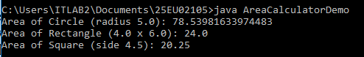
  - Develop a Java program to pass a Student object as a parameter to a method and display the student details
class Student { private int id;
private String name; private double gpa;

// Constructor to initialize student fields
public Student(int id, String name, double gpa) { this.id = id;
this.name = name; this.gpa = gpa;
}

// Getters for accessing private fields public int getId() {
return id;
}

public String getName() { return name;
}

public double getGpa() { return gpa;
}
}

public class StudentPassDemo {

// Method that accepts a Student object as a parameter public static void displayStudentDetails(Student student) {
System.out.println("--- Student Profile ---"); System.out.println("ID: " + student.getId());

System.out.println("Name: " + student.getName()); System.out.println("GPA: " + student.getGpa());
}

public static void main(String[] args) {
// Create a Student object
Student student1 = new Student(101, "Emma Watson", 3.9);

// Pass the Student object to the display method displayStudentDetails(student1);
}
}
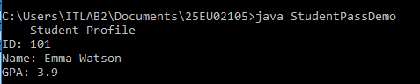
  - Write a Java program to pass two Employee objects to a method that compares their salaries and displays the employee with the higher salary.
class Employee { private String name; private double salary;

public Employee(String name, double salary) { this.name = name;
this.salary = salary;
}

public String getName() { return name;

}

public double getSalary() { return salary;
}
}

public class EmployeeSalaryComparison {

// Method accepting two Employee objects as parameters
public static void compareAndDisplayHigherSalary(Employee emp1, Employee emp2) { if (emp1.getSalary() > emp2.getSalary()) {
System.out.println(emp1.getName() + " has a higher salary ($" + emp1.getSalary() +
").");
} else if (emp2.getSalary() > emp1.getSalary()) {
System.out.println(emp2.getName() + " has a higher salary ($" + emp2.getSalary() +
").");
} else {
System.out.println("Both " + emp1.getName() + " and " + emp2.getName() + " have equal salaries ($" + emp1.getSalary() + ").");
}
}

public static void main(String[] args) {
Employee emp1 = new Employee("Alice", 75000.00); Employee emp2 = new Employee("Bob", 82000.50);

System.out.println("--- Employee Salary Comparison ---"); System.out.println("Employee 1: " + emp1.getName() + " ($" + emp1.getSalary() + ")");

System.out.println("Employee 2: " + emp2.getName() + " ($" + emp2.getSalary() + ")"); System.out.println();

// Pass both Employee objects to the comparison method compareAndDisplayHigherSalary(emp1, emp2);
}
}
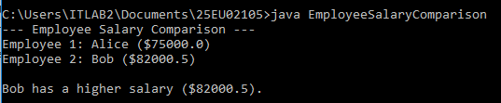

  - Develop a Java program in which a method creates and returns a Student object. Display the returned object's details.
class Student { private int id;
private String name; private double gpa;

// Constructor
public Student(int id, String name, double gpa) { this.id = id;
this.name = name; this.gpa = gpa;
}

// Method to display student details public void displayStudentInfo() {
System.out.println("Student ID : " + id);

System.out.println("Student Name : " + name); System.out.println("Student GPA : " + gpa);
}
}

public class StudentReturnDemo {

// Method that instantiates and returns a Student object
public static Student createStudent(int id, String name, double gpa) { Student newStudent = new Student(id, name, gpa);
return newStudent; // Returning the object reference
}

public static void main(String[] args) {
// Call method to create and retrieve the Student object
Student student1 = createStudent(105, "Samantha Reed", 3.95);

// Display details of the returned Student object System.out.println("--- Returned Student Details ---"); student1.displayStudentInfo();
}
}
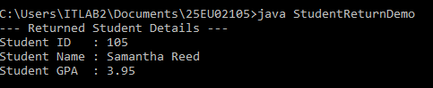

  - Write a Java program in which a method updates the balance of a BankAccount object and returns the updated object.

class BankAccount {
private String accountNumber; private String accountHolder; private double balance;

public BankAccount(String accountNumber, String accountHolder, double balance) { this.accountNumber = accountNumber;
this.accountHolder = accountHolder; this.balance = balance;
}

public void setBalance(double balance) { this.balance = balance;
}

public double getBalance() { return balance;
}

public void displayAccountInfo() { System.out.println("Account Number : " + accountNumber); System.out.println("Account Holder : " + accountHolder); System.out.println("Current Balance: $" + balance);
}
}

public class BankAccountReturnDemo {

// Method that updates the balance and returns the modified BankAccount object public static BankAccount updateBalance(BankAccount account, double amount) {
double newBalance = account.getBalance() + amount; account.setBalance(newBalance);
return account; // Returns the reference to the updated object
}

public static void main(String[] args) {
BankAccount acc = new BankAccount("ACC-9081", "Marcus Vance", 1200.00);

System.out.println("--- Initial Account Details ---"); acc.displayAccountInfo();

// Pass object and amount to update function System.out.println("\nProcessing deposit of $450.50..."); BankAccount updatedAcc = updateBalance(acc, 450.50);

System.out.println("\n--- Updated Account Details ---"); updatedAcc.displayAccountInfo();
}
}
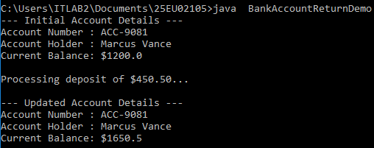

  - Develop a Java program to count the total number of Student objects created using a static variable.
class Student {
private String name; private int id;

// Static variable shared across all instances of Student class private static int objectCount = 0;

// Constructor increments static variable whenever an object is instantiated public Student(String name, int id) {
this.name = name; this.id = id; objectCount++;
}

// Static getter method to access the private static count variable public static int getObjectCount() {
return objectCount;
}

public void displayStudentInfo() { System.out.println("ID: " + id + " | Name: " + name);
}
}

public class StudentCountDemo {
public static void main(String[] args) {

System.out.println("Initial object count: " + Student.getObjectCount());

// Creating student objects
Student s1 = new Student("Alice", 101); Student s2 = new Student("Bob", 102); Student s3 = new Student("Charlie", 103);

System.out.println("\n--- Student List ---"); s1.displayStudentInfo(); s2.displayStudentInfo(); s3.displayStudentInfo();

// Accessing static method directly using Class Name
System.out.println("\nTotal Student objects created: " + Student.getObjectCount());
}
}
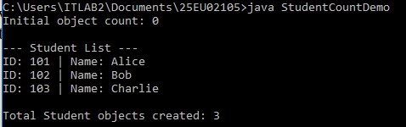

  - Write a Java program to create a utility class containing static methods for calculating the square, cube, and factorial of a number.
class MathUtils {

// Private constructor prevents instantiation of this utility class private MathUtils() {}

// Static method to calculate the square of a number public static double square(double number) {
return number * number;
}

// Static method to calculate the cube of a number public static double cube(double number) {
return number * number * number;
}

// Static method to calculate the factorial of an integer public static long factorial(int n) {
if (n < 0) {
System.out.println("Error: Factorial is undefined for negative numbers."); return -1;
}
long result = 1;
for (int i = 1; i <= n; i++) { result *= i;
}
return result;
}
}

public class MathUtilityDemo {
public static void main(String[] args) { double val = 4.0;
int factVal = 6;

// Calling static utility methods directly using the class name System.out.println("--- Math Utility Calculations ---"); System.out.println("Square of " + val + " : " + MathUtils.square(val)); System.out.println("Cube of " + val + " : " + MathUtils.cube(val));
System.out.println("Factorial of " + factVal + " : " + MathUtils.factorial(factVal));

// Edge case check: negative input for factorial System.out.println("\nNegative Factorial Check:"); System.out.println("Result: " + MathUtils.factorial(-5));
}
}
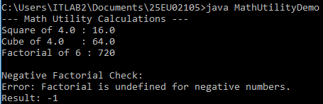

  - Develop a Java program to demonstrate the use of final variables, final methods, and final classes.
// 1. Final Class: Cannot be subclassed/extended final class SystemConfig {
public void displayConfig() {
System.out.println("System configuration loaded successfully.");
}
}

// Class Attempting to extend SystemConfig will cause a compiler error:

// class CustomConfig extends SystemConfig {} // ERROR: Cannot inherit from final SystemConfig

class BaseDevice {
// Final Variable: Constant value that cannot be reassigned once initialized private final String serialNumber;

public BaseDevice(String serialNumber) {
this.serialNumber = serialNumber; // Primary initialization
}

// 2. Final Method: Cannot be overridden by child classes public final void showSerialNumber() {
System.out.println("Serial Number: " + serialNumber);
}

public void powerOn() { System.out.println("Device powering on...");
}
}

class SmartPhone extends BaseDevice { public SmartPhone(String serialNumber) {
super(serialNumber);
}

// Attempting to override showSerialNumber() will cause a compiler error:
// @Override
// public void showSerialNumber() {} // ERROR: cannot override final method

@Override
public void powerOn() {
System.out.println("SmartPhone powering on with custom boot screen.");
}
}

public class FinalKeywordDemo { public static void main(String[] args) {
// --- 1. Final Variable ---
final int MAX_USERS = 100; // Final local variable System.out.println("--- Final Variable ---"); System.out.println("Max Users Allowed: " + MAX_USERS);
// MAX_USERS = 200; // ERROR: Cannot assign a value to final variable

// --- 2. Final Method ---System.out.println("\n--- Final Method ---");
SmartPhone phone = new SmartPhone("SN-9982-XYZ"); phone.showSerialNumber(); // Calls inherited final method phone.powerOn();

// --- 3. Final Class ---System.out.println("\n--- Final Class ---");
SystemConfig config = new SystemConfig(); config.displayConfig();
}
}

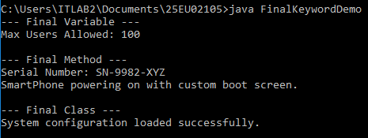

  - Write a Java program to initialize a blank final variable through a constructor and use it to assign a unique employee ID.
class Order {
private static int idCounter = 5000; // Static counter for generating IDs

// Blank final variable (uninitialized at declaration) private final int orderId;
private String item;

// Constructor initializes the blank final variable public Order(String item) {
this.orderId = ++idCounter; // Assigned once during object creation this.item = item;
}

public void displayOrderDetails() {
System.out.println("Order ID: " + orderId + " | Item: " + item);
}
}

public class OrderDemo {

public static void main(String[] args) {
Order order1 = new Order("Wireless Mouse"); Order order2 = new Order("Mechanical Keyboard"); Order order3 = new Order("Gaming Monitor");

System.out.println("--- Order Processing ---"); order1.displayOrderDetails(); order2.displayOrderDetails(); order3.displayOrderDetails();
}
}
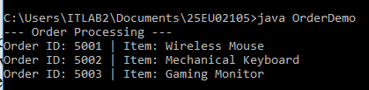

  - Develop a Java program to create a College class containing a static nested
Department class. Display the department details. class College {
private static String collegeName = "Apex Institute of Technology";

// Static nested class static class Department {
private int deptId; private String deptName;
private String headOfDept;

public Department(int deptId, String deptName, String headOfDept) { this.deptId = deptId;

this.deptName = deptName; this.headOfDept = headOfDept;
}

public void displayDepartmentDetails() {
System.out.println("College Name : " + collegeName); // Accessing static member of outer class
System.out.println("Department ID: " + deptId); System.out.println("Department : " + deptName); System.out.println("Head of Dept : " + headOfDept); System.out.println(" ");
}
}
}

public class CollegeDemo {
public static void main(String[] args) {
// Instantiating the static nested class directly via the outer class name
College.Department csDept = new College.Department(101, "Computer Science", "Dr. Alan Turing");
College.Department eeDept = new College.Department(102, "Electrical Engineering", "Dr.
Nikola Tesla");

System.out.println("--- Department Details ---"); csDept.displayDepartmentDetails(); eeDept.displayDepartmentDetails();
}
}

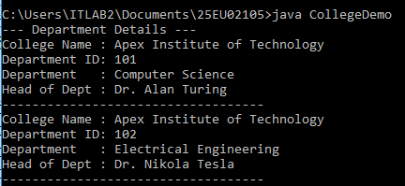
  - Write a Java program to create an Employee class with a static nested Address class and demonstrate accessing the nested class from the main method.
class Employee { private String name; private int id;

public Employee(String name, int id) { this.name = name;
this.id = id;
}

// Static nested class static class Address {
private String city; private String state; private String zipCode;

public Address(String city, String state, String zipCode) { this.city = city;
this.state = state; this.zipCode = zipCode;
}

public void displayAddress() {
System.out.println("City: " + city + ", State: " + state + ", ZIP: " + zipCode);
}
}

public void displayEmployeeInfo(Address address) { System.out.println("Employee ID: " + id + " | Name: " + name); System.out.print("Address : ");
address.displayAddress();
}
}

public class EmployeeAddressDemo { public static void main(String[] args) {
// Instantiating the static nested Address class directly via OuterClass.NestedClass Employee.Address address = new Employee.Address("Austin", "Texas", "73301");

// Instantiating the outer Employee class
Employee emp = new Employee("Sarah Jenkins", 201);

System.out.println("--- Employee Details ---"); emp.displayEmployeeInfo(address);
}
}
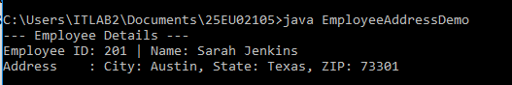

  - Develop a Java program to create a Student class containing an inner Address class. Display the student and address information.
class Student { private int id;
private String name;

public Student(int id, String name) { this.id = id;
this.name = name;
}

// Non-static inner class class Address {
private String city; private String state; private String zipCode;

public Address(String city, String state, String zipCode) { this.city = city;
this.state = state; this.zipCode = zipCode;
}

public void displayStudentDetails() {
// Direct access to outer class private fields (id, name) System.out.println("Student ID : " + id); System.out.println("Student Name : " + name); System.out.println("City : " + city);

System.out.println("State : " + state); System.out.println("ZIP Code : " + zipCode);
}
}
}

public class StudentAddressDemo { public static void main(String[] args) {
// 1. Instantiate outer Student object
Student student = new Student(101, "Alex Morgan");

// 2. Instantiate non-static inner Address object using outer instance Student.Address address = student.new Address("Seattle", "Washington", "98101");

System.out.println("--- Student & Address Information ---"); address.displayStudentDetails();
}
}
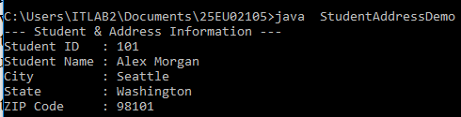
  - Write a Java program to create a Library class containing an inner Book class. Demonstrate how the inner class accesses the members of the outer class.
class Library {
private String libraryName; private String location;

public Library(String libraryName, String location) { this.libraryName = libraryName;
this.location = location;
}

// Non-static inner class class Book {
private String title; private String isbn;

public Book(String title, String isbn) { this.title = title;
this.isbn = isbn;
}

public void displayBookDetails() { System.out.println("Book Title : " + title); System.out.println("ISBN : " + isbn);

// Direct access to outer class private instance variables System.out.println("Library Name : " + libraryName); System.out.println("Location : " + location);

// Explicit outer reference using OuterClass.this syntax
System.out.println("Full Context : " + Library.this.libraryName + " (" + Library.this.location + ")");
}
}
}

public class LibraryDemo {
public static void main(String[] args) {
// Create an instance of the outer class
Library cityLibrary = new Library("Metropolitan Public Library", "Central District");

// Instantiate the inner class through the outer class reference
Library.Book book = cityLibrary.new Book("Effective Java", "978-0134685991");

System.out.println("--- Book & Library Details ---"); book.displayBookDetails();
}
}


